Getting Started with the Schoology Mobile App
Schoology has a mobile app that allows users to access Schoology on the go.
The mobile app can be downloaded for Android and iOS devices to provide users with quick and easy access to many of Schoology’s features.

Schoology Mobile App for iOS Devices
Step One
Search for and download the Schoology App from the App Store.
Step Two  Type Baltimore County Public Schools in to the Log in Through Your School box and click Continue.  You will see three options for Baltimore County Public. Select the option with the green dot on the right-hand side. | 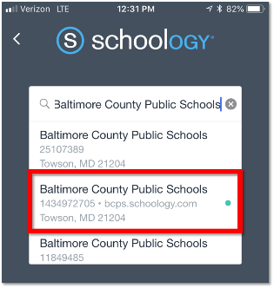
Step Three
Log in with your BCPS One credentials.
Step Four  From your Schoology App you will now be able to access your BCPS Schoology Account. Many of the general Schoology features such as Messages, Notifications, Student Activity, Courses, Groups, Resources, and Grades can be accessed from the menu icon. | 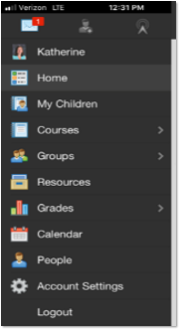

Getting Started with the Schoology Mobile App
Schoology has a mobile app that allows users to access Schoology on the go.
The mobile app can be downloaded for Android and iOS devices to provide users with quick and easy access to many of Schoology’s features.

Schoology Mobile App for Android Devices
Step One
Search for and download the Schoology App from the Google Play Store.
Step Two  Type Baltimore County Public Schools in to the Log in Through Your School box and click Continue.  You will see three options for Baltimore County Public. Select the option with the green dot on the right-hand side. | 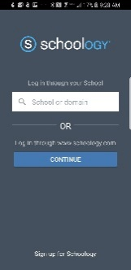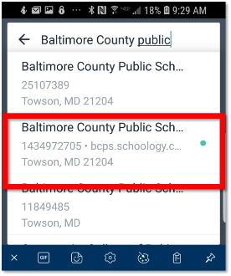
Step Three
Log in with your BCPS One credentials.
Step Four  From your Schoology App you will now be able to access your BCPS Schoology Account. Many of the general Schoology features such as Messages, Notifications, Student Activity, Courses, Groups, Resources, and Grades can be accessed from the menu icon. | 